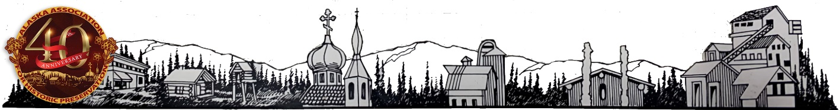

Alaska Association for historic preservation, inc.
PO Box 102205 Anchorage, AK 99510 907.929.9870 AKPreservation@gmail.com

AAHP BOARD OF DIRECTORS NOMINATION FORM
Deadline for nominations is October 1, 2022
WHAT IS THE ALASKA ASSOCIATION FOR HISTORIC PRESERVATION (AAHP)?
AAHP is a private, statewide, 501c3 non-profit corporation dedicated to the preservation of Alaska’s prehistoric and historic resources through education, promotion, and advocacy. To achieve this mission of historic preservation in Alaska, AAHP maintains several internal and external committees, programs, and partnerships overseen by a Board of Directors and managed by Corporation staff. AAHP adheres to the principle that preservation of the built environment provides a vital link and visible reminder of the past, emphasizing the continuity and diversity of Alaska.
BOARD OF DIRECTOR PROFILE
Nominees should be at least eighteen years of age, live in Alaska, and have experience in one or more of these areas:
- Alaska history
- Historic preservation
- Public education
- Media and public relations experience
- Financial or organizational management of nonprofit organizations
- Parliamentary procedures/Legal expertise
Members should have an interest, knowledge, or professional qualifications in the areas of historic preservation, historic rehabilitation, archaeology, anthropology, or Alaska history, and the ability to work well in a group. In addition, the AAHP Board looks for members who are willing to commit time and energy to committee work and who exhibit sensitivity in making constructive critical judgments.
To help reflect the diversity of the state, the AAHP Board considers geographic representation, and cultural background when appointing advisors. In addition, the organization seeks balance among the professional groups encompassed by historic preservation, such as practitioners, administrators, and educators.
HOW MUCH TIME DOES ADVISORY SERVICE TAKE?
Board of Director positions are 3-year terms beginning in the corporate year of January to December. The time commitment depends on which committee the member serves. The Board meets monthly, and committees should meet monthly depending upon committee work. Members are expected to study orientation materials in advance of the meetings.
WHAT HAPPENS WHEN I SUBMIT A NOMINATION?
The Nomination Committee chair creates a file for each nominee that includes his or her completed nomination form and resume. The nominee will be considered for appointment as vacancies occur. If the nominee is interested in serving on a committee, she or he should check the appropriate box on the nomination form. Otherwise, the nominee will be considered for positions based on his or her background and experience.
WHAT ABOUT CONFLICTS OF INTEREST?
As a 501c3, AAHP has strict rules governing conflict of interest to ensure fairness in all operations. Members are requested to declare any conflicts of interest prior to any discussion. Declaring a conflict does not mean that a member cannot serve; it merely means that the member must be recused during such situations.
Conflicts of interest include:
- Receiving direct financial benefit from an applicant organization or a project being reviewed;
- Serving as an employee or governing board member of an applicant organization being reviewed;
- Serving with or without pay as a consultant to an applicant, on the application being reviewed;
- Familial relationship with an applicant, staff, or board member of an applicant organization.
Members who feel unduly biased or have a personal affiliation with an AAHP project or program are expected to declare an “apparent” conflict of interest. Apparent conflicts of interest include nonfamilial cohabitants, as well as significant adversarial or advocacy relationships in which an advisory’s ability to be impartial is impaired.
EQUAL OPPORTUNITY AND ACCESS
AAHP warrants that it is an Equal Opportunity and provides access to everyone to participate in and benefit from programs of AAHP that is provided to all individuals regardless of race, national origin, color, sex, age, religion, sexual orientation, or disability in admission, access or employment. All Board or committee meetings are held in an accessible location and via teleconference. Upon request, AAHP Board materials will be made available in an alternate format.

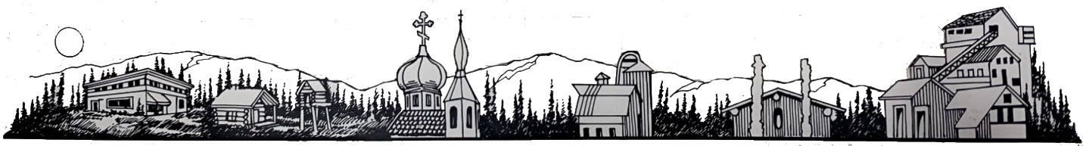
Alaska Association for historic preservation, inc.
PO Box 102205 Anchorage, AK 99510 907.929.9870 AKPreservation@gmail.com

BOARD OF DIRECTORS MEMBER NOMINATION FORM
Candidate Information
Name: _________________________________________________
Home address: ___________________________________________
Phone number: ___________________________________________
E-mail address: ___________________________________________
Employment/Position: ______________________________________
Education _______________________________________________
Note of interest in becoming an AAHP Board member (use continuation sheet if necessary):

Previous experience (if any) with (name or org):

Please check any of the following skills or experience that the candidate possesses.

Administration/Management
❐ Accounting, Financial Management
❐ Entrepreneurship
❐ Communications
❐ Marketing
❐ PR
❐ Strategic planning
❐ History
❐ Governance (board leadership/operations)
❐ IT
❐ Fundraising
Grant Writing
❐ Government
❐ Law
❐ Mission-related
❐ Special Events Planning
❐ Nonprofit experience
❐ Teaching experience, curriculum development
❐ Other: ________________

If not selected for the board, I would be interested in serving on a committee. __Yes ___No
If not selected, I would be interested in serving on the advisory board. __Yes ___No

Affiliations or organizations the candidate belongs to (e.g., membership, professional, civic) . ____________________________________________________________________________________________________________________________________

Short biography for the ballot (use continuation sheet if necessary):

Submitted by
Name: _________________________ Date: _______________________
Phone _________________________ E-mail: ______________________
Has this person been contacted to determine their interest in being nominated? __ Yes ___No
Thank you for your nomination
Please submit nomination form via email or mail to:
Alaska Association for Historic Preservation, Inc.
P.O. Box 102205
Anchorage, Alaska 99510-2205
akpreservation@gmail.com
(907) 929-9870
https://alaskapreservation.org

