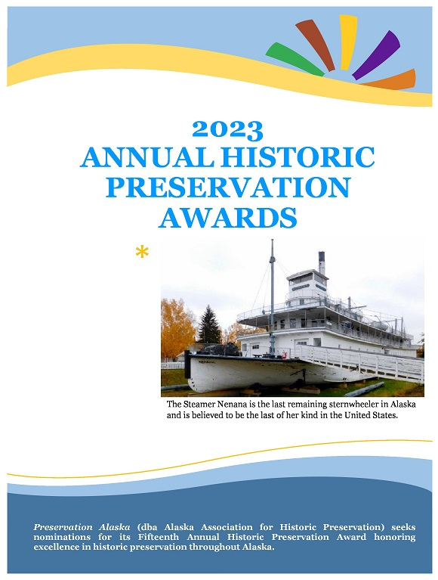

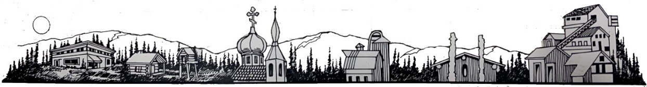2023 ANNUAL HISTORIC PRESERVATION AWARDS
Preservation Alaska (dba Alaska Association for Historic Preservation) seeks nominations for its Fifteenth Annual Historic Preservation Award honoring excellence in historic preservation throughout Alaska.
The purpose of the Historic Preservation Award recognizes significant contributions to the preservation of Alaska’s historic resources and to recognize a project, organization, agency, or individual who exemplify the highest standards among Alaska preservation. The awards are open to projects completed within the last 25 years. Nominations are reviewed by the Preservation Awards Committee. Awards are presented at annual meeting held the first Thursday of November.
For clarification or inquiries, please contact Preservation Alaska at 907.929.9870 or via email at AKpreservation@gmail.com

AREAS OF EXCELLENCE EXAMPLES
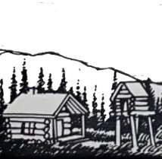
- Lifetime Achievement

Includes individuals who have demonstrated a lifetime commitment to historic preservation and whose vision and activities have significantly impacted preservation in Alaska.

Robert Mitchell Historic Preservation Architect Award
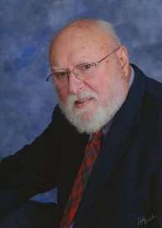
This award is in memory of Robert Mitchell, long-time board member of Preservation Alaska and his work as an historic preservation architect. Bob was presented the Historic Preservation Award for Lifetime Achievement in 2015, in honor of his outstanding service to the field of historic preservation and architecture over the years. With two university degrees (one in architecture from University of Pennsylvania), Bob opened an architectural practice in Montana in 1961. In 1975, he became a Design Manager for the Alaska Department of Public Works, then transferred to the Alaska State Historic Preservation Office (SHPO). After that, Bob spent ten years working for the North Dakota SHPO. After

Robert Mitchell
returning to Alaska, he remained active in historic preservation.
Bob joined the AAHP Board in 2005 and helped to found Friends of Nike Site
Summit in 2007. Playing a major role in both organizations, Bob was always hands on with the restoration work at Nike Site Summit, and his knowledge, expertise, and enthusiasm made him an invaluable AAHP board member. With his career spanning almost six decades, we salute his lifetime personal commitment and achievements in historic preservation by creating this special award for architects specializing in historic preservation.
For award nomination criteria please see page 5.

- Adaptive Use, Stabilization, Renovation, and Restoration Projects

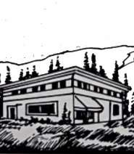
Includes historic buildings and archaeological/historic sites that have been successfully stabilized, renovated, restored or adapted for a new use within the past five years. Residential, commercial, civic, cultural, and religious projects considered. Prior projects, up to 25 years old, may be considered at the discretion of the awards jury. Projects must be complete and still being used in order to be eligible.

- Stewardship Award
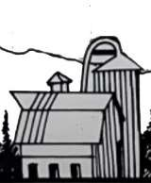
The Stewardship Award recognizes those who have ensured the preservation of historic properties through long-term care and maintenance, stabilization, protection, or continuous family ownership.

“At its best, preservation engages the past in a conversation with the present over a mutual concern for the future. – William Murtagh

  - Property Owners
Includes property owners who exemplify the value of stewardship by preserving the historic character of an historic building or archaeological/historic site over time through regular and appropriate maintenance. Residential, commercial, civic, cultural, and religious properties are considered.

  - Organizations
Includes organizations involved in furthering historic preservation in Alaska. Organizations may be recognized for a variety of activities undertaken within the past five years, such as: educational programs, events to raise public awareness of preservation, advocacy, publications/media, planning, and the protection of historic buildings and archaeological/historic sites from destruction.

  - Firms and Governmental Agencies
Includes professional firms and governmental agencies whose work has furthered preservation in Alaska. Firms and agencies may be recognized for a variety of projects undertaken within the past
25 years, such as: feasibility studies; planning and survey documents; advocacy; infill design in historic districts; and renovation, restoration, and adaptive use designs.

  - Individuals
Includes individuals who have made a significant contribution to historic preservation in Alaska in the last 25 years. Individuals may represent a variety of disciplines and may be volunteers, grassroots activists, craftsmen, or paid professionals.

  - Historic Advocacy
Sometimes an outstanding project champion should be recognized for organizing both the funding and people into the right places rather than having any specific preservation skills. This person may be a non-professional as well as a professional.

NOMINATION PROCEDURES

Nominations for the 2023 Historic Preservation Awards must include a nomination form and appropriate supporting materials. Nomination materials will be kept permanently in Preservation Alaska’s files and will not be returned.
- Project must be located within the state of Alaska.
- Project must be complete.
- Only projects completed within the past 25 years will be considered.
- Project must be listed or eligible for listing in the National Register of Historic Places.

All Nominations should include:
- Nomination Form
- A typed narrative describing the project, property owner, organization, firm, agency, or individual being nominated.
- The narrative should include the purpose and scope of the project/activity/contribution, innovative approaches used by the nominee, the long-range impact of the project/activity/contribution, and any additional information that supports the project/activity/ contribution as exemplary in Alaska preservation.
  - A list of all parties involved who should receive recognition.
  - Beginning and ending dates of project
  - Visual materials as appropriate including photos, digital images, architectural drawings, or site plans. All visuals must be labeled. Photographs must be at least 300 dpi (high resolution).
  - If applicable, a copy of the regular maintenance schedule for the building or site may be included.
  - Examples of any work products related to the nomination (e.g., a copy of the publication, video,
study, or other materials)
  - Up to three letters of support are encouraged, but not required.

NOMINATION DEADLINE – FOR ALL NOMINATIONS
Complete submission must be postmarked no later than October 10, 2023. You may email your submission to AKpreservation@gmail.com or mail to:
Alaska Association for Historic Preservation, Inc.
PO Box 102205
Anchorage, AK 99501-2205

AWARDS PRESENTATION
The Historic Preservation Award recipient will be notified of their award on or before October 31, 2023. All nominees and their preservation contributions will be honored at Preservation Alaska’s Historic Preservation Awards Ceremony and Annual Meeting to be held in Anchorage in November. The annual meeting will be a combined in person and Virtual event. (In case of health issues, the event may be entirely a Virtual event. Awards will be delivered or mailed to the recipients.)

Robert Mitchell Historic Preservation Architect Award Nomination Criteria 2022
Winners Receive
- Prestigious handmade, one-of-a-kind award valued at over $150; opportunity to purchase additional awards.
- Printed award certificate for each project team member.
- Recognition at the Annual Meeting and Awards Presentation held on November 4, 2021.
- Regional promotion in AAHP’s Preservation Notes Newsletter.
- Promotion on Preservation Alaska’s website and social media platforms.
- Statewide public relations announcement.
Nomination Criteria
- Projects will be judged by a jury of preservation professionals based on the following criteria:
  - Creative or unique approach to design, adaptive reuse, and problem solving in the field of historic preservation.
  - Exceptional quality of engineering, craftsmanship, materials, and standards Significant positive economic, cultural, or environmental impact to the community.
Eligibility
- Residential or commercial projects must be completed within the last five years with the building age at least 50 years old, and fit the following eligibility:
- Rehabilitation/redevelopment of a structure, public space, or cultural landscape at least 50 years old Compatible addition to a historic building or infill development within a historic district.
- Completed in Alaska within the last five years.
- Self-nominations will be accepted.
Nomination Categories
A jury of preservation professionals will consider each nomination for outstanding contributions made in the state of Alaska in the following categories:
- Commercial.
- Public/government.
- Residential.
- Compatible Addition to Historic Building or Infill Development in a Historic District Rural/agricultural property.
- Park, plaza, fountain, or cultural landscape.
Application Materials Required
The following materials are required:
- Application answers.
- Complete Project Team List: Must provide complete information for the project team including company name, contact person, email and mailing information and the role served (preferably an Excel worksheet).
- Photos & Supplemental Information: Support your nomination and narrate the compelling story of this project with photos. Include historic photo(s) if available, “Before,” “In Process” and “After” images that illustrate what makes your project exceptional.
- Photo/Image Criteria:
File names should be the same for each.
For example: Project Name_Front Entrance_Historic.jpg Project Name_Hallway_Historic.jpg.
- Photos must include captions/cutlines and photo credit/copyright information
- Photos must be at least 300 dpi. jpeg is preferred. Color or black and white.
- Complete nomination application may be emailed or via DropBox. A hard copy is required.

Alaska Association for Historic Preservationist Historic Preservation Awards for 2021

Nomination Deadline October 10, 2023

Nominee:

Address of Nominee: City: State: Zip:

Phone(s): E-mail:

Areas of Excellence (check one):

Lifetime
Achievement Projects Stewardship

Robert Mitchell Historic Architect Award

  - ☐ Adaptive Use
    - Stabilization
    - Renovation
    - Restoration
    - Property Owner
    - Organization
    - Firm/Governmental Agency
    - Individual
    - Historic Advocacy

See page 4
for nomination criteria. Nomination Form on page 8

Nomination submitted by:

Affiliation with nominee:

Address:

City: State: Zip:

Phone(s): E-mail:

Nomination Form Information For the Following Awards
Life Achievement – Projects – Stewardship

A typed narrative describing the project, property owner, organization, firm, agency, or individual being nominated.

The narrative should include the purpose and scope of the project/activity/contribution, innovative approaches used by the nominee, the long-range impact of the project/activity/contribution, and any additional information that supports the project/activity/ contribution as exemplary in Alaska preservation.

      - A list of all parties involved who should receive recognition.
      - Beginning and ending dates of project
      - Visual materials as appropriate including photos, digital images, architectural drawings, or site plans. All visuals must be labeled.
      - If applicable, a copy of the regular maintenance schedule for the building or site may be included.
      - Examples of any work products related to the nomination (e.g., a copy of the publication, video, study, or other materials)
      - Up to three letters of support are encouraged, but not required.

Robert Mitchell Historic Preservation Architect Award Nomination Form Project Name:
Project Address: Property Owned By: Year Originally Built: Date Project Completed: Project Budget: $

- Is the property recognized for its significance by any of the following? National Historic Landmark, National Register of Historic Places, Local Historic Designation

- List any federal, state or local tax credits or other incentives received. Would the project have happened without these incentives?

- Did the project follow the Secretary of the Interior's Standards for the Treatment of Historic Properties? Yes/No

- Has this project received other recognition or awards? (Include copies or links to news articles if available)

- Provide an overview of the project and its historic significance or context. (Please limit to three paragraphs)

- Were there any unusual constraints, parameters, or challenges, and how did you address them? (Please limit to three paragraphs)

- What is the one most exceptional aspect of this project and why? (Please limit to three paragraphs)

- What lessons were learned that could benefit others embarking on similar projects? (Please limit to three paragraphs)

